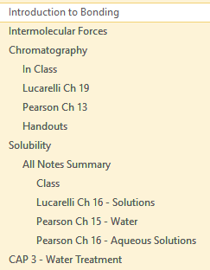
In each section the pages will look something like this – the top-level pages (not indented) are subtopics, and they contain notes from class and textbooks as subpages. The summary of each subtopic is in the top-level page.

Bolded notes are generally definitions.

↑Temperature = ↑E_{K} = ↑Collision frequency + ↑Collisions with energy $≥$ E_{a} = ↑Successful Collisions
I often use arrows and equals signs to make the notes shorter and less wordy – up/down arrows are increase/decrease, and the equals signs mean like “leads to”.
For example: The note above essentially means “increasing the temperature leads to an increase in kinetic energy, which leads to increased collision frequency and collisions with energy greater than or equal to the activation energy, leading to more successful collisions.

The course outline and information about experiments and data are in the Atomic Structure section.

If you see a ‘+’ button to the left of a note, it means it can be expanded by double clicking on it
